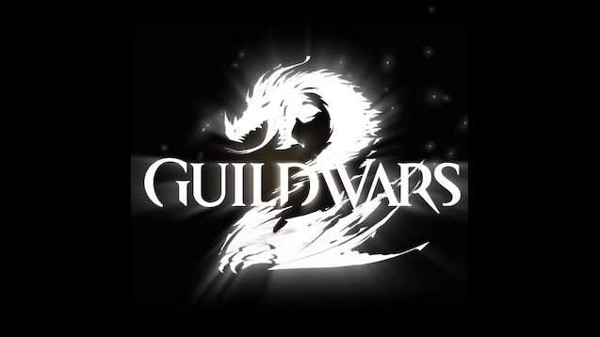

GUILDWARS 2 Fractals Introduction Guide

An introduction to the basics from Fractals of the Mists.

By Minerva Frostleaf AKA Kenar Solmen

Guardian of the united[gotu] & Exodus/z of the elder dragons/z[GODS]   EU based

Fractals of the Mists

The Fractals of the Mists are mini-dungeons, each with their own short story and environment. They are split into 4 tiers (difficulty rating) each consisting of 25 fractals. Meaning that there are 100 Fractals in total to complete. These mini-dungeons need to be completed with 5 man parties and will get you specific rewards, achievements and gear which is unique to the Fractals of the Mists.

Your personal Fractal level will determine which fractals you can start if your leading the party and is raised by completing Fractals which you have not yet completed. However if you join a party with someone who has a higher Fractal level they can enable you to join for that one[1].

This guide will cover a few of the basics regarding the Fractals when you want to start on it and covering the intro to the Mistlock Observatory (the starting area).

1. Fractals:

As mentioned the Fractals themselves are mini dungeons with 4 tiers of difficulty.

These are referred to as T1, T2, T3 and T4 in case CM is mentioned in combination with this it refers to Challenge Motes being active for the Fractal. But as this is a starter guide this won’t be covered here.

Each Fractal rewards you with Fractal Encryptions which can be unlocked with a key for rewards, some of it is junk which can be worth 25 silver to 1 gold. But it can also contain rarer items such as Ascended Rings/Gear at higher levels (don’t expect that frequently before T4 though). Besides this you will get +1 Agony Infusions and Fractal Relics which are a currency to buy specific items.

While ascending through the Fractal levels you can expect to experience the following changes:

* Level 1-19 can be done without AR (Agony Resistance) which from level 20 onward will affect the players by reducing health every 3 seconds and reducing healing effects by 70%. The higher the Fractal level, the more AR is required to mitigate the effects.
* In general the higher you get the greater the numbers of enemies will be as well as their respective levels. Also some new skills will appear on enemies at higher levels which aren’t there in the lower level fractals.
* Mistlock Instabilities will start appearing from level 26 onward with additional ones being added at level 51 and level 76. Which means 3 ‘negative’ effects are on you at the highest levels. These range from not being able to be close to your fellow players to damaging conditions.
* From level 71 onward a Fractal Avenger will spawn when your downed to kill you with a finisher like other players do in PvP or WvW. Moving or being put in Stealth help prevent this.
* There are no Waypoints in the Fractals but there are Checkpoints which when reached will ensure you don’t spawn at the beginning on Death.

Each Fractal has it’s own mechanics, learning these makes it far easier to get through them with your party.

1. The Mistlock Observatory:

This is the area you enter when you go into the Fractals of the Mists portal through the center portal at the Mist Portals in Fort Marriner, Lion’s Arch. When entering it a pop-up will show for you to confirm which fractal level you would like to start, this list will be limited by your personal fractal level.

In the Observatory the following things can be found:

* 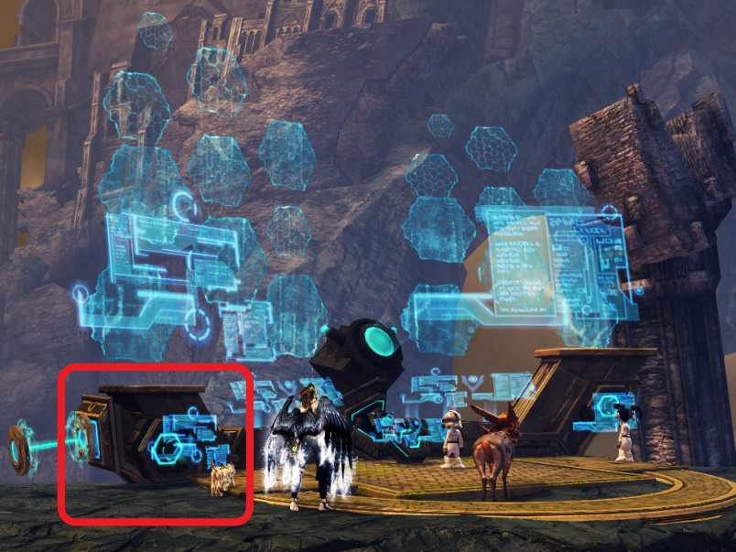The Fractal Scale Setting Sequencer where you can change the fractal you want to play by selecting it.
* Daily fractals[2] and daily recommended will be highlighted with a purple orb on the screen when you talk to it. The daily ones give additional rewards when completed.

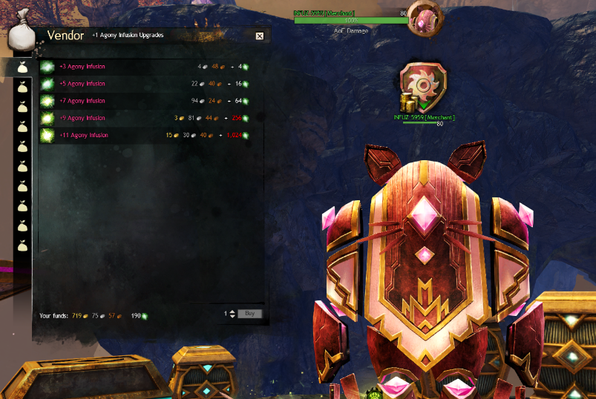

* INFUZ-5959 (red) who sells Agony Resistance upgrades[3] of higher levels in exchange for a combination of lower levels and a bit of gold, silver or bronze. Besides this it also sells Mist Essences (Globs, Vials and Shards) which are required for crafting infusions and upgrading ascended rings.

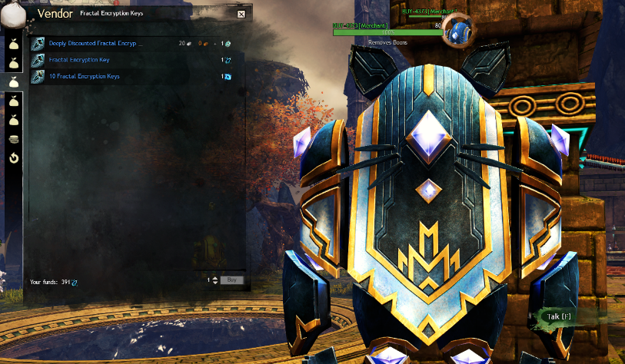

* BUY-4373 who sells Deeply Discounted Fractal Encryption Keys and Ascended Salvage Kits.

Note that only the Deeply Discounted Fractal Encryptions Keys are worth buying and that they are limited to 30 a day.

* Afbeelding met binnen, vrouw, klein, vasthouden

  Automatisch gegenereerde beschrijvingDessa’s Alchemist who sells the Massively Discounted Anguished Tear of Alba which raises the AR resistance by 10 for 1 hour. After buying 5 potions on your account it will change and become a slightly more expensive until 25 in total have been bought. After which it is set.

Also other boosting potions can be bought if required.

* 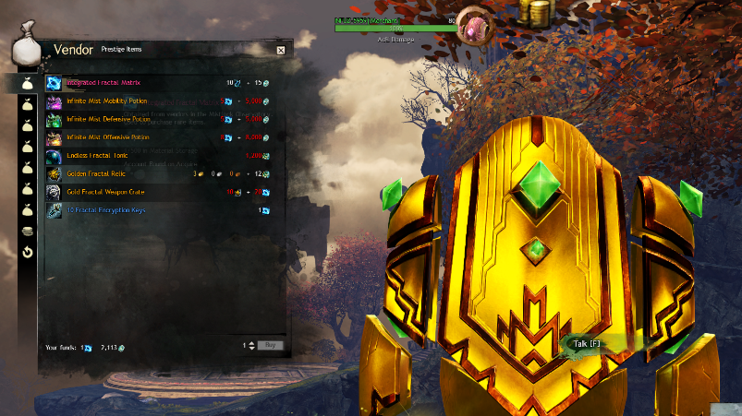INFUZ-5959 (gold) is the Prestige Vendor who sells Infinite Mist Potions (permanent upgrades to Defense, Offense and Mobility in the Fractals) and items such as Ascended armor and weapons.

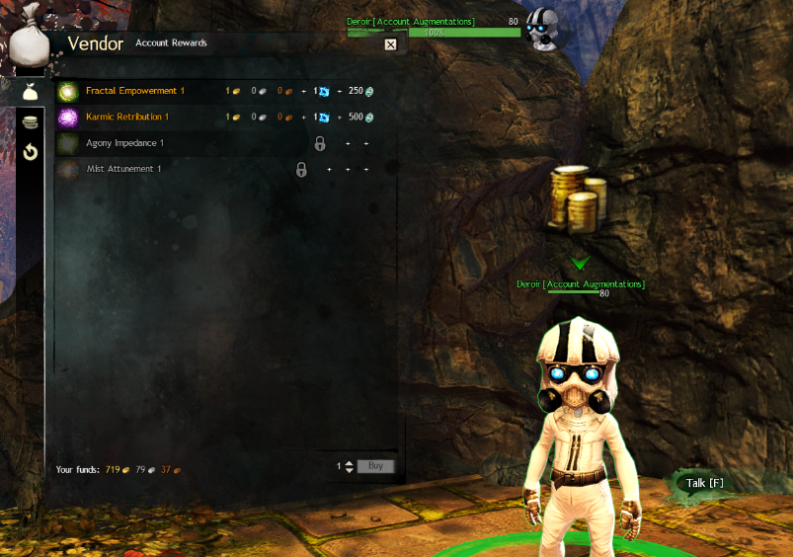

* Deroir, who sells permanent boosts for the Fractal rewards. These boosts are account bound and cover 4 tiers.
* Afbeelding met groen, tafel, licht, zitten

  Automatisch gegenereerde beschrijvingFractal Instability Trainer, this little golem as his name states gives you the option to practice and experience the effects of the Instabilities you may encounter while playing the Fractals.

Besides this there is also a NPC called Kelvei, the Legendary Observer who will help you get started on the Ad Infinitum backpack. And finally there is a jumping puzzle in the Observatory along with diving goggles.

1. Fractal Masteries

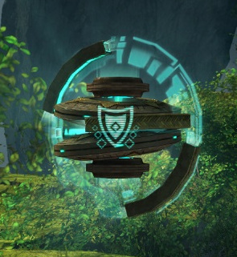There are 4 Fractal Attunement Masteries which can be unlocked:

* Follows Advice: this will enable the Daily Fractal Achievements for additional rewards and unlock some of the vendors in the Mistlock Observatory.
* Agony Channeler: This will improve rewards in a Fractal boss chests and ingredients for attuning rings will now be sold at the NPC’s as well as Mist Potions.
* Recursive Resourcing: Increases the value of rewards as well as the possibility to receive Unlocked Fractal Encryptions. Also Fractal Potions will become more effective.
* Mistlock Singularities: This will allow you to trigger the Mistlock Singularities as shown on the side to trigger Rigorous Certainty which recharges all skills on cooldown, repairs equipped armor and grant an additional small bit of AR and toughness, precision and concentration if the related potions are active for the player.

1. Additional points of attention

* AR (agony resistance) comes in the shape of infusions meaning you need ascended armor or at least trinkets to get those equipped. There are more ‘luxurious’ versions which also give stat boosts besides the AR.
* Attuning & Infusing ascended rings will ensure you get 2 additional slots on each of the rings for the AR infusions.
* There are AR benchmarks which people look for, now there are guides on wiki showing the most cost efficient way etc. but for the different tiers the following AR levels will ensure you easily get through said tier:
  + T1: 17 AR (for the last 6 levels)
  + T2: 61 AR
  + T3: 106 AR
  + T4: 150 AR (this reduced the continuous damage to 1%)

Now the above information is to get you started on the Fractals of the Mists and so you know what the basics are you will run into. The most important thing though is to get the mechanics down for each of the Fractals as at the higher levels the consequences of not knowing the mechanics will not only hurt you while playing but will also hamper your party from progressing.

So take your time on T1 and T2 to get to know the mechanics and enjoy the little stories in there!.

1. Note that the Fractal level will also limit your LFG options to the Tier until which you’ve got it unlocked.
2. Note that doing Fractals on a higher tier will give all rewards for the lower Tiers as well. So if the Dailies are done for T4 it will trigger also the rewards for the same Fractal at T1, T2 and T3.
3. You can also craft them yourself with +X AR infusions if you have Artificing as a crafting skill.